ONE-PAGE ABSTRACT TEMPLATE AND GUIDELINES –TITLE CENTERED AND ALL CAPS

First name Family name of Primary Author, Affiliation, Email address
First name Family name of next author, Affiliation
First name Family name of next author, Affiliation
First name Family name of next author, Affiliation
First name Family name of Primary Author, Affiliation, Email address of the corresponding author (if applicable)

Key Words: Not more than five key words

This guideline is prepared for the Poster abstract submission. Authors should submit the Poster abstract according to the format. The Poster abstracts book will be printed in A4, and the Page size is 210mm×297mm, top and bottom margin 2.54 cm, left and right margin 3.18 cm. The title of the abstract should be written in Arial, 12 pt. The Body text should be written in Arial, 10.pt, one and a half spacing. The Abstract should be in English, introducing the research’ background, methods, results, conclusions and the other related contents. References may be included at the bottom.

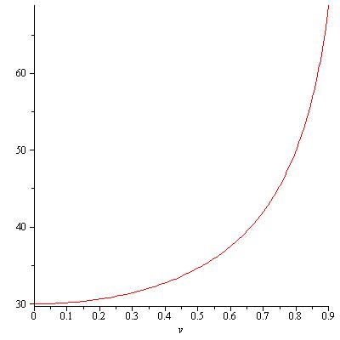
The abstract may contain images, graphs or tables to help draw attention to the subject matter, but it should be noted that these will be printed in black and white. The abstract must not exceed one page.
Figure 1 – Arial 10 pt Italics

Please do not insert page numbers or headers and footers. These will be added later by the publisher. Abstracts should be submitted to the email: mes2019@tib.cas.cn

Please proofread your abstract carefully prior to submission.
The abstract shall be submitted as Word File (.doc or .docx).

