Prof. Dr.-Ing. Vera Meyer  Berlin University of Technology  Institute of Biotechnology  Department Applied and Molecular Microbiology  Gustav-Meyer-Allee 25  13355 Berlin  Tel.: +49 30 314 72750  Fax: +49 30 314 27922  e-mail: vera.meyer@tu-berlin.de | 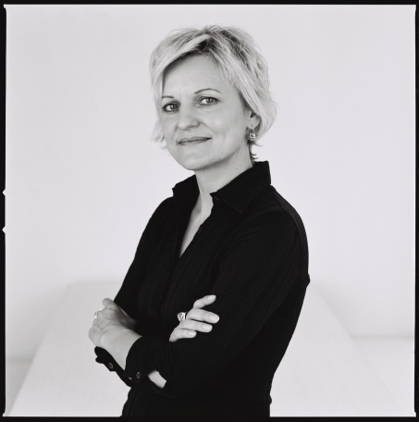

Scientific Career:
since 2011 | Full Professorship in Applied and Molecular Microbiology at the Technische Universität Berlin
2008-2011 | Assistant professor at Leiden University, Department Molecular Microbiology and Biotechnology, Leiden, Netherlands
2008 | Habilitation at the Department of Microbiology and Genetics at the Technische Universität Berlin
2005-2006 | Visiting scientist at Leiden University, Department Fungal Genetics and Metabolomics, Leiden, Netherlands
2003 | Visiting scientist at Imperial College of Science, Technology and Medicine, Department Infectious Diseases and Microbiology, London, GB
2002-2008 | Research assistant and group leader at the Department of Microbiology and Genetics, Technische Universität Berlin
2001 | Doctoral degree as Dr.-Ing. at the Department of Microbiology and Genetics at the Technische Universität Berlin
1989-1996 | Study of Biotechnology at the Universität Sofia (Bulgaria) and Technische Universität Berlin, Degree: Diplom-Ingenieurin Biotechnologie

Research Interest:
- Optimizing product formation in fungal production systems
- Production of bioactive substances using fungal production systems
- Development of new antifungal agents and strategies
- http://www.mikrobiologie.tu-berlin.de/menue/research/parameter/en/
Executive Board Member
- Aspergillus Genome Research Policy Committee
- Eurofung Consortium
- German Society for Chemical Engineering and Biotechnology (DECHEMA), Section Biotechnology
- German Society for General and Applied Microbiology (VAAM)

Grants
- 2005-2008. German Federal Ministry for Education and Research “Improvement of exopolysaccharide production of Sclerotium rolfsii by metabolic engineering”; €503,000
- 2008 – 2012. Dutch Kluyver Centre of Excellence, “Cell architecture of Aspergillus niger”; €425,000
- 2010 – 2013. Dutch Kluyver Centre of Excellence, “Phosphoproteomics of the cell architecture of Aspergillus niger”; Kluyver Centre, €337,000
- 2012 – 2016: EU Marie Curie Grant “Bridging the world of fungi and dementia”, €100,000
- 2013 – 2017: EU Marie Curie International Training network, “QuantFung” €3.800,000

