Evolution of Natural Products for Cancer Chemotherapy
Jürgen Rohr
Department of Pharmaceutical Sciences, College of Pharmacy, University of Kentucky, 789 S. Limestone St, Lexington, Kentucky 40-536-0596, USA
jrohr2@email.uky.edu
Natural products always had a major impact on drug discover, particularly for clinical cancer chemotherapeutics, which are ~70% natural product derived. Yet, the natural products themselves are often not optimal, due to toxicity, instability or solubility issues. But the modification of natural products, which are usually too complex for a practical total synthesis, requires a fundamental understanding of their biosynthetic pathways, which in turn enables modification strategies based on combinatorial biosynthesis (pathway engineering) or chemo-enzymatic modifications, such as mutasynthesis or chemical derivatizations. The exact sequence of events in biosyntheses of natural products is essential not only to understand and learn from nature’s strategies and tricks to assemble complex natural products, but also for yield optimization of desired natural products, and application of the above mentioned bio-modification strategies. Classical biosynthetic studies including incorporation experiments, crossfeeding experiments, and genetic studies (gene cluster determination and gene inactivation) led to many proposals of biosynthetic pathways, but often just through in silico analyses of the biosynthetic gene clusters. Investigations of the complex biosyntheses of the aureolic acid group and some examples of the angucycline group of anticancer drugs (mithramycin, landomycin, gilvocarcin) revealed that applied classical methods failed to delineate the true biosynthetic sequence of events. In order to unambiguously assign enzyme activities, in vitro pathway reconstitution and systematic studies and recombination of its enzyme components (combinatorial biosynthetic enzymology) turned out to be the only way to delineate the complex post-polyketide tailoring steps toward these anticancer natural products. This not only revealed intriguing multifunctional and/or co-dependent enzymes but also allowed to unambiguously assign the involved enzymes, and corrected many of the earlier drawn hypotheses and conclusions.

References
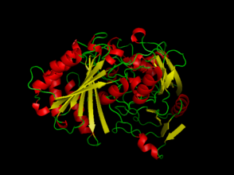
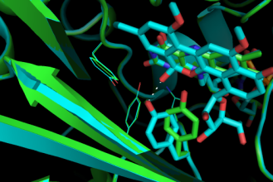
a) Pahari P., Kharel M.K., Shepherd M.D., Van Lanen S.G., Rohr J., Angew. Chem. Int. Ed. 2012, 51 (5), 1216-1220; b) Wang, G. Pahari, P., Kharel, M.K., Chen, J., Zhu, H., Van Lanen, S.G., Rohr , J., Angew. Chem Int. Ed. 2012, 51, 10638-10642; c) Kharel, M. K., Rohr, J., Curr. Opin. Chem. Biol. 2012, 16, 150-161; d) Bosserman, M.A., Downey, T., Noinaj, N., Buchanan, S.K., Rohr, J., ACS Chem. Biol. 2013, 8, 2466-2477; e) Scott, D., Chen, J.-M., Bae, Y., Rohr, J., Chem. Biol. Drug Des. 2013, 81, 615-624.
 | Jürgen Rohr received his education at the University of Göttingen, Germany, and graduated with a PhD in Organic Chemistry (major) and Microbiology (minor). He was post-doc in Prof. Heinz Floss’ laboratory at the Department of Chemistry of the Ohio-State-University, Columbus, Ohio, USA. He took his current position as Full Professor at the College of Pharmacy of the University of Kentucky in 2002, and is the Director of the Division of Drug Discovery since 2007. Before joining University of Kentucky, Dr. Rohr was Assistant Professor at the Department of Chemistry and Biochemistry of the University of Göttingen, Germany, and Associate Professor at the Department of Pharmaceutical Sciences of the Medical University of South Carolina, Charleston, SC, USA. His research interests span isolation and structure elucidation of natural products, biosynthetic studies of microbial natural products, combinatorial biosynthesis, enzymology and chemo-enzymatic derivatization, with focus on polyketide anticancer drugs.

